FAA and Eurocontrol Pursue Initial Trajectory-Based Operations Now, Full Implementation Later
Air traffic management driven by Trajectory Based Operations (TBO) is the ultimate goal of the NextGen and SESAR air traffic modernization programs. In this article, we provide a status update on the deployment and enablement of TBO in both regions.
Avionics International (July-August 2022)
Dave Hughes
The FAA is in the initial stages of setting up trajectory-based operations (TBO) in the National Airspace System on a path for developing “full and dynamic” TBO after 2030.
Full and dynamic TBO will include 4D trajectory management, path stretch, airborne flight negotiation and multiple airport route separation (designed to enable time-based sequencing and spacing of air traffic).
TBO is an air traffic concept designed to enhance strategic air traffic planning using precise aircraft trajectory data (latitude, longitude, altitude and time) showing where the aircraft is expected to be on its route from take-off to touchdown.
The FAA has already implemented some initial TBO capabilities in areas designated as the Northeast Corridor (New York and Philadelphia TRACONs), the Northwest Mountain Region (Denver TRACON), and the Southwest (Los Angeles TRACON). The Mid-Atlantic Region (Atlanta TRACON) will be involved soon.
The FAA says it has the infrastructure in place to allow TBO to function in automation systems that can communicate with one another, according to Wendy O’Connor of AJT-3 in the Air Traffic Organization. She is the lead in the FAA for TBO deployment.
FAA automation systems already project trajectories based on aircraft models. The agency has demonstrated that its systems can be more precise when exchanging individual trajectories with aircraft and operators. The modelling tools currently in use employ uncertainty buffers and the tools may be modified to support greater flight efficiencies.
The methods for negotiating new routes and clearances based on the exchange of precise trajectories is a concept the FAA is still fleshing out with ongoing analysis.
The Air Traffic Organization is leading the implementation of TBO but all FAA organizations are working together on analysis, studies, concept development, acquisition and implementation. Each FAA modernization program has a piece in TBO “since it goes from airspace design with Performance Based Navigation (PBN) procedures to improved strategic and tactical flow all the way to improvement in conflict predictions,” according to O’Connor. “It is much more than just trajectory exchanges, it has been about modernizing all of the NAS to utilize the advancement in air and ground automation, navigation and information exchange.”
The FAA is working with other air navigation service providers to understand the needed communications and integration of systems in order to implement TBO around the world. These efforts are in synch with flight and flow guidance being developed by ICAO panels. There are working level investigations and demonstrations underway with international partners to ensure harmonization. In addition, there is a multi-nation TBO demonstration in the works with a group of nations to validate information exchanges and messaging.
The Status of TBO in Europe
According to Eurocontrol, the path to greater ATM capacity requires greater precision, higher granularity and improved data sharing in particular with predicted flight trajectories. Enhanced data sharing will improve Collaborative Decision Making (CDM). Europe is taking the initiative with Common Project 1 to deploy new ATM concepts and technology moving toward trajectory and performance-based operations.
Eurocontrol aims to begin initial operations this year by implementing the Release 1 services defined by the ICAO Flight & Flow information for a collaborative environment to govern pre-departure data exchanges and procedures including flight plans with 4D trajectory information. Aircraft “extended projected profile reports” will be shared over ADS-C. Implementation in other phases of flight will follow.
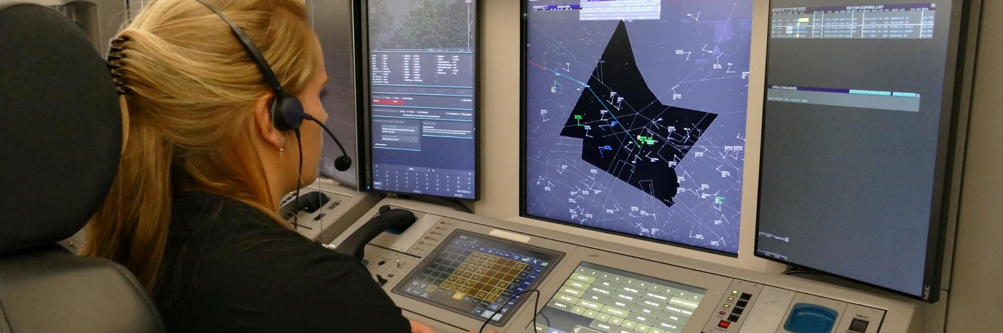Air Traffic Controllers at Eurocontrol’s Maastricht Upper Area Control Centre, pictured here, started using ATS B2 Automatic Dependent Surveillance – Contract (ADS-C) via the aeronautical telecommunications network (ATN) in May. Eurocontrol sees the implementation at MUAC as a major step toward trajectory-based operations. Eurocontrol
In Europe, ANSPs already exchange relevant flight data for tactical coordination and transfer of flights between neighbouring centres. Eurocontrol’s Network Manager (NM) coordination facility and systems supported by CDM provides regional ATM that will also ensure connection to global ATM. Technology is enhancing ATM services while improved procedures and SWIM related information exchanges will move Europe into the mainstream information exchange paradigm.
TBO sharing of information including trajectories from flight planning to arrival at the gate will happen though it is not clear yet when and how this will occur, according to Eurocontrol. A “big bang” transition is not considered feasible but Eurocontrol NM will move forward while supporting old and new operations. New elements will be introduced gradually in the decade ahead allowing a smooth transition to initial TBO operations, Eurocontrol adds.
Eurocontrol NM is already coordinating, arbitrating, disseminating and maintaining flight data during flight planning/filing and is kept up to date on changes in flight data/trajectory before departure. It will be updated to do the same to meet TBO/CDM objectives. “This includes evaluation and re-evaluations of the flight trajectories against all applicable constrains and conditions which might affect the flight.”
Several major players across various segments of Europe’s air transportation industry have also collaborated in recent years to introduce the concept of 4D operations.
In March 2019 for example, U.K.-based easyJet became the first airline operating in European airspace to receive Airbus A320s equipped with avionics capable of enabling 4D initial trajectory sharing. Onboard avionics necessary to enable 4D trajectory operations include new data link routers, upgraded flight management systems and data link compatible cockpit displays.
Other airlines that have operated A320s with the FANS-C avionics configuration capable of 4D initial trajectory sharing include Air France, British Airways, EasyJet, Iberia, Novair, Thomas Cook and Wizz Air. In October 2021, Airbus launched a new large-scale demonstration project involving Airbus, Air France and DSNA, the French Air Navigation Service Provider (ANSP) called "ALBATROSS" tasked with demonstrating how the use of 4DT can reduce fuel and CO2 emission savings on flights operated by Air France and other airlines throughout European airspace.
Just last month, easyJet also became the first European carrier to sign on as a partner for Inmarsat and the European Space Agency’s (ESA) Iris program. Iris, developed in a public-private partnership launched by ESA, is a service designed to offer high bandwidth and cost-effective satellite datalink communications between air traffic controllers and pilots. It allows aircraft to send and receive live data with ground systems during the entire flight.
Eurocontrol NM will assess local changes to see if they will have downstream network impact. Network planning will not override any ANSP considerations for what happens in their airspace. NM implemented post-departure procedures will synchronize all individual trajectories with all concerned actors while disseminating flight data updates when ANSPs make changes and alter downstream flight intent.
The Future of TBO in U.S. Airspace
Steve Fulton has been working on government/industry committees engaged in efforts to improve the efficiency of air navigation for 30 years. He co-chaired the PBN Time, Speed, Spacing Task Group commissioned by the NextGen Advisory Committee in 2016 which reviewed and reported on the FAA’s plans for key elements of infrastructure required to support TBO. He thinks most of the people he worked with agree that air traffic management has to move from a tactical to a strategic approach to directing traffic based on times of arrival at key points rather than miles in trail. While some approaches to this concept have been tried such as choreographing time, speed and spacing – accomplishments have fallen short of goals established in 2016, he believes. Tactical control adds tens of minutes to arrivals and burns more fuel which adds to the carbon footprints of aircraft.
Fulton thinks government regulators and the aviation industry have an opportunity in the coming of unmanned traffic management (UTM) and the air traffic control of air taxis in urban areas to implement time-based management. This is an opportunity to accomplish trajectory-based operations and once it is successful there at low altitudes it can be moved to traditional airspace at higher altitudes where airlines, business jets and piston-powered aircraft operate. He notes that the machines using high speed numerical methods create drone shows at sporting events. “The drone swarms can do unbelievable manoeuvres with pre-determined positions beyond the capabilities of the human mind,” he said. Machine learning and artificial intelligence may be useful tools.
Fulton said this new air traffic arena is “white space” where new concepts can be tried and refined as he did in Juneau for Alaska Airlines in designing Required Navigation Procedures (RNP). Aircraft using TBO will fly precise 4D PBN paths. Fulton and his team have developed RNP procedures in the United States, Canada, China, Australia, New Zealand and South America.
What it will take more than anything to make TBO happen is good leadership. “There needs to be a focused, driving force with clarity and single mindedness on policy to get us from here to there,” he said.
John Walker, is a former FAA senior executive now an air traffic consultant who works on a half dozen standards, technical and industry committees. He said the key to transforming air traffic management to accommodate large scale UAS and eVTOL operations is in how airspace should be used. Airspace is seldom looked at as being part of air transportation infrastructure so it is easily overlooked as the key to modernization.
“Airspace is designed like a 1955 Chevy and we are trying to put a Tesla with 2022 bells and whistles in it,” Walker said. “Airspace in the United States will not sustain current or future growth of platform innovation such as eVTOL or UAS or unmanned cargo aircraft,” he said.
Air traffic management must move from tactical to strategic control and TBO will be a key part of this.
Walker co-chairs the Airspace Working Group on the Aerospace Industries Association Emerging Technologies Committee. The airspace effort focuses on how equal access can be provided for new and existing users of airspace and proposes using an “innovative, unique and provocative strategy for achieving near-term access.” The planning is moving along as the AIA group builds a process scenario with MITRE CASD modelling to come up with recommendations. “We need a fundamental change in the use of airspace,” Walker said. The initial focus is on use of airspace below 3,000 feet in Los Angeles and New York.

