October 1, 2021
FOR IMMEDIATE RELEASE:
PEREGRINE PARTNERS WITH MEDEVAC OPERATOR FOR CABIN AIR CLEANING SYSTEM
Peregrine, Peak Medevac International and Haggan Aviation partnered to develop a STC for Learjet 35 and 60 installations of the Aviation Clean Air (ACA) ionic air cleaning system for use in medevac aircraft. This system, part of a multi-layered sanitization program utilizes ionic air cleansing to protect the medevac flight crew and patients from airborne and surface pathogens. A supplemental type certificate (STC) will soon be available from Peregrine.
“With the continuing concern with the COVID-19 pandemic and our commitment to transporting medical patients with the greatest degree of care, we are confident that the Peregrine-developed installation of the ACA ionization system improves the aircraft environment for our patients and crews,” stated Eugene Haggen, CEO of Peak Medevac.
Installation of the compact ACA system into the environmental control system (ECS) ducting provides continuous removal action during the entire aircraft ground and air operation and is the key to complete and continuous defense against pathogens. All pressurized areas of the aircraft are infused with positive and negative ions that neutralizes viruses and other pathogens using the ACA unique needle point bipolar ionization (NPBI™) system fitted to the aircraft ECS airflow.
“Working closely with Peak Medevac and Haggen Aviation, we jointly developed an installation for these aircraft popular in the medevac fleet. The system operates continuously without flight crew interaction, providing a turn-key solution for medevac operations,” said David Rankin, president of Peregrine

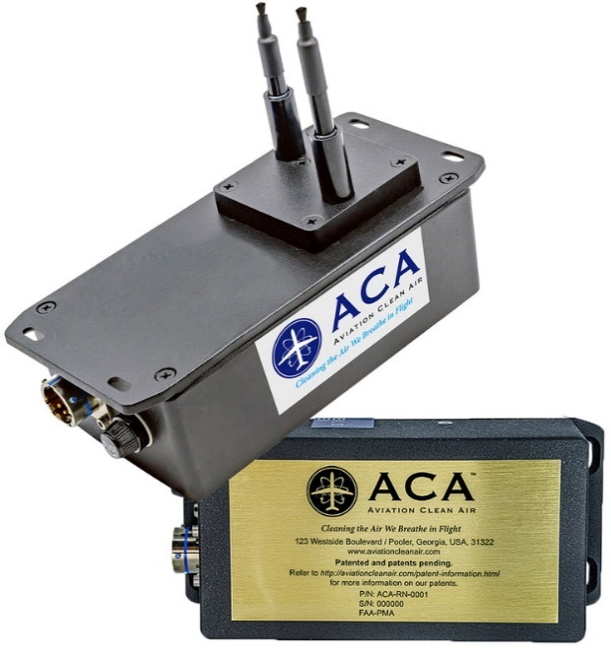
Figure 1: ACA NPBI™ Unit Weighs Only 1.34 lbs, Unit Dimensions are 7.02” x 3.27” x 5.36” (w/Probes Extended)
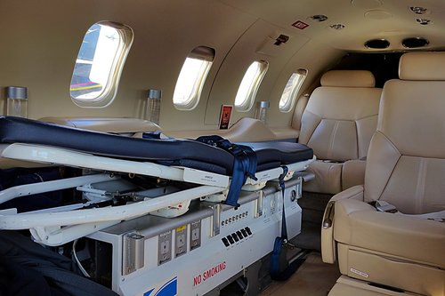
Figure 2: Interior view of a Peak Medevac International cabin environment treated by the ionic disinfection system
Peregrine has also developed Supplemental Type Certificate (STC) and Approved Model List (AML) for the Citation 560XL
The Aviation Clean Air units offer a proactive air and surface purification system for aircraft, providing immediate clean, safe, and healthy interior air. In addition to removing odors and allergens, their patented and proven, needle point bipolar ionization (NPBI™) system installed in the aircraft environmental control system, kills pathogens throughout the cockpit, cabin and pressurized cargo areas. The system eliminates pathogens including, but not limited to:
- COVID-19
- Bacteria associated with SARS
- Bird Flu (H5N1)
- Swine Flu (H1N1)
- Staph
- Eliminating mold spores, MRSA, E.coli, Tuberculosis, C.diff, pneumonia and more
Testing at an independent laboratory showed that the ACA system was 99 percent effective in eliminating SARS-CoV-2 (COVID-19).
Peregrine Avionics, LLC, is an aircraft engineering and certification firm located at Centennial Airport in Englewood, CO. Over its 10-year history Peregrine has obtained over 25 STCs and provided extensive design and analytical support for Parts 23, 25, 27 and 29 aircraft. It is currently awaiting approval of its application for Organization Designation Authorization. Additional details can be found at peregrine.aero
Haggan Aviation, located at Centennial Airport (KAPA) just south of Denver, Colorado, is a full-service FAA-approved Part 145 repair station specializing in small to mid-size jet maintenance. Our team of factory-trained experts are up-to-date with the latest avionics systems and mandates and will provide installations and upgrades to meet your needs.
Established in 1996, Haggan Aviation offers full airframe inspections, engine maintenance, avionics, major retrofits for cabin and cockpit systems, as well as paint and interior capabilities. In addition, Haggan provides complete Wi-fi and in-flight entertainment installations to create the ultimate onboard experience. For more information, visit www.hagganaviation.com/
Peak Medevac International, is the premier long distance medical transport company operating in the western hemisphere. With our dedicated fleet of air ambulance jets that are owned, operated, and maintained- highly trained critical care teams, and multilingual case management and medical coordination teams, we are unmatched in our ability to serve our clients.

###

