Peregrine
7385 S. Peoria Street Unit C4
Englewood, CO 80112
303 325-3873
www.peregrine.aero

December 1, 2020
FOR IMMEDIATE RELEASE:

PEREGRINE STC INTRODUCES ACA AIRCRAFT AIR DISINFECTION SYSTEM FOR CITATION 560 XL
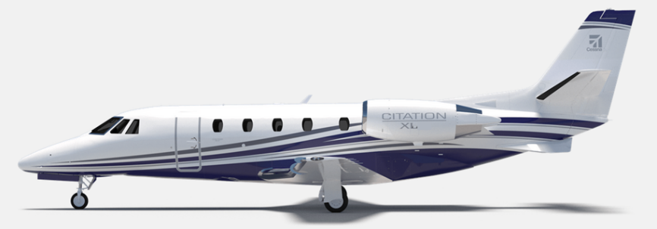
Peregrine announces Citation 560XL first-of-type US FAA STC availability of the Aviation Clean Air (ACA) active pathogen disinfection technology, including eradication of COVID-19 virus. The process uses ACA’s unique, patented and proven, needle point bipolar ionization (NPBI™) system installed in the aircraft environmental control system. The air in the pressurized aircraft areas is continually infused with positive and negative ions that effectively neutralizes a wide range of viruses and other pathogens, as well as neutralizing the COVID-19 virus.
Figure 1: Cessna Citation 560XL
The system installation data and US FAA Supplemental Type Certificates (STCs) for 560XL aircraft is now available from Peregrine. Peregrine-developed STCs for the ACA system are also available for aftermarket installation in the Gulfstream G-IV and GIV-SP models, Falcon 50 and 900, in addition to the Bombardier CL600 series family. Peregrine expects to announce additional air certification agency validations for these STCs to support greater accessibility to this technology.
“We are pleased to incorporate this all-important health protection ACA system in our own company’s aircraft after developing STCs for other aircraft with Peregrine.” commented Jim Lee, founder and president of Lee Aerospace, who provided the 560XL STC aircraft.
“This system implements a layered defense for protecting aircraft passengers and crew by supplementing cleaning procedures with an active, always-on system that provides continuous, effective neutralization of harmful pathogens.” Lee stated. “This installation and the other collaboratively developed STCs demonstrate the availability of the ACA system to users and operators of all sizes of business aircraft.”

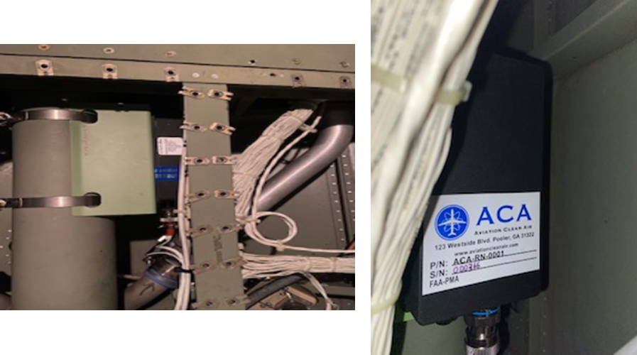
Figure 2: The ACA NPBI™ unit weighs less that one pound (right) and installs on the existing ECS output ductwork (left) to provide continuous protection from harmful pathogens.
ACA units are a proactive air and surface purification technology installed in the aircraft environmental control system ductwork giving crew and passengers immediate clean, safe and healthy interior air. In addition to removing odors and allergens, its patented ionization technology kills pathogens throughout the aircraft pressurized areas including baggage/ cargo spaces. The ACA systems efficacy neutralizes many viruses including COVID-19, Bird Flu (H5N1), Swine Flu (H1N1) and bacteria such as associated with SARS, Staph as well as eliminating Mold Spores, MRSA, E.coli, T.B., C.diff, Pneumonia and more. Testing for SARS-CoV-2 (COVID-19) effectiveness validation performed by an independent laboratory demonstrates over 99% effectivity.
Peregrine Avionics, LLC, is an aircraft engineering and certification firm located at Centennial Airport in Englewood, CO. Over its 10-year history Peregrine has obtained over 25 STCs and provided extensive design and analytical support for Parts 23, 25, 27 and 29 aircraft. It is currently awaiting approval of its application for Organization Designation Authorization.
Lee Aerospace, LLC, designs, manufactures, repairs and distributes acrylic aircraft windows, aerostructure assemblies, composite parts, sheet metal wing spars and fuselage assemblies for the aerospace market. Located in Wichita, KS, Lee Aerospace has been in business for over 30 years.
###

