Peregrine Western Aircraft
7385 S. Peoria Street Unit C4 4300 S Kennedy St.
Englewood, CO 80112 Boise, ID 83705
303 325-3873 (208) 338-1800
www.peregrine.aero info@westair.com

November 19, 2020
FOR IMMEDIATE RELEASE:

PEREGRINE AND WESTERN AIRCRAFT: STC FOR GOGO AVANCE L3 AIRBORNE CONNECTIVITY FOR PILATUS PC-12
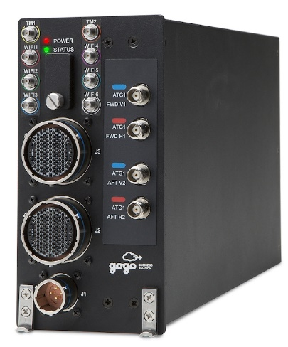
On behalf of Western Aircraft, Peregrine completed a supplemental type certificate (STC), STXXXXDE, installing the Gogo AVANCE L3 airborne connectivity solution for the popular Pilatus PC-12 aircraft. The AVANCE L3 system provides unmatched email/VPN/Web, Voice/Text, Inflight entertainment, cockpit app data and simple operation is available with continuous inflight connectivity.
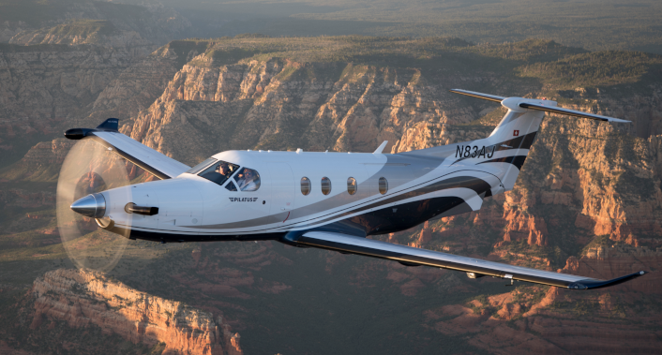
“We are pleased to work with Western Aircraft and Gogo to bring affordable airborne connectivity to this popular aircraft.” said David Rankin, president of Peregrine. “Inflight access to vital communications reduces downtime and further illustrates the value of business aviation.”
“Our customers and their passengers can enjoy and benefit from the connectivity that they are used to while they are on the ground, in their offices and vehicles while they are inflight.” stated Xxxx Xxxxxx, customer experience manager of Western aircraft. “This STC brings high-throughput communications capabilities previously available only in larger business aircraft.”
Peregrine Avionics, LLC, is an aircraft engineering and certification firm located at Centennial Airport in Englewood, CO. Over its 10-year history Peregrine has obtained over 25 STCs and provided extensive design and analytical support for Parts 23, 25, 27 and 29 aircraft. It is currently awaiting approval of its application for Organization Designation Authorization.
Western Aircraft, one of ten aerospace components of Greenwich AeroGroup, is an authorized service center, certified aircraft repair station (FE6R532N) and worldwide distributor of parts and avionics for many of the world’s top aircraft manufacturers and OEMs such as Dassault Falcon, Pilatus, Embaer, Beechcraft, King Air, Cessna, Piper, Quest, Honeywell and Collins
Gogo is the Inflight Internet Company. We are the leading global provider of broadband connectivity products and services for aviation. We design and source innovative network solutions that connect aircraft to the Internet and develop software and platforms that enable customizable solutions for and by our aviation partners. Once connected, we provide industry leading reliability around the world. Our mission is to help aviation go farther by making planes fly smarter, so our aviation partners perform better and their passengers travel happier.
You can find Gogo's products and services on thousands of aircraft operated by the leading global commercial airlines and thousands of private aircraft, including those of the largest fractional ownership operators. Gogo is headquartered in Chicago with additional facilities in Broomfield, Colo., and locations across the globe. Connect with us at gogoair.com.

###

